You have given a Map of Romania. Represent this graph in dictionary.

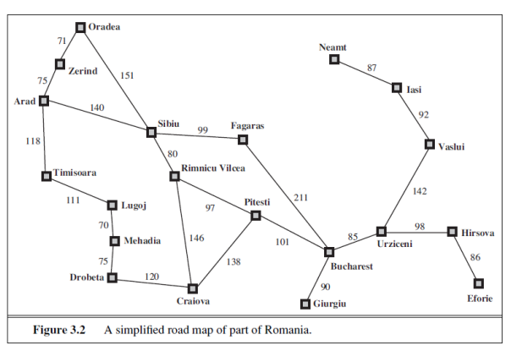

1. Apply BFS on given graph by considering the starting node as Arad and goal node as Bucharest.

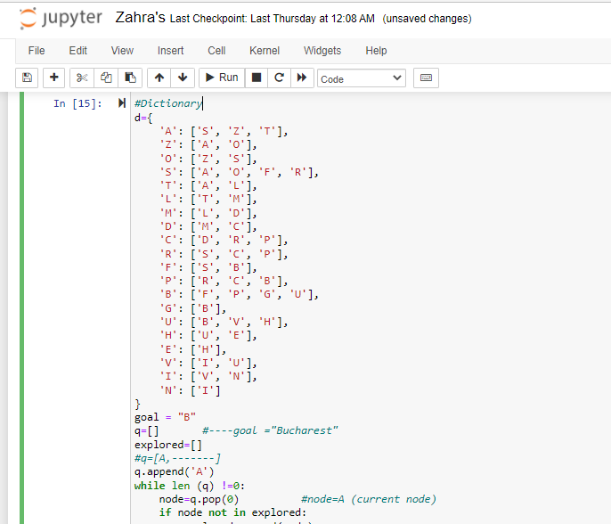

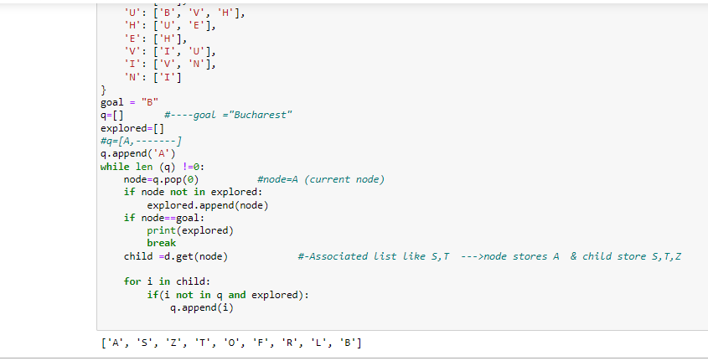

1. Apply BFS on given graph by considering the starting node as Oradea and goal node as Bucharest.

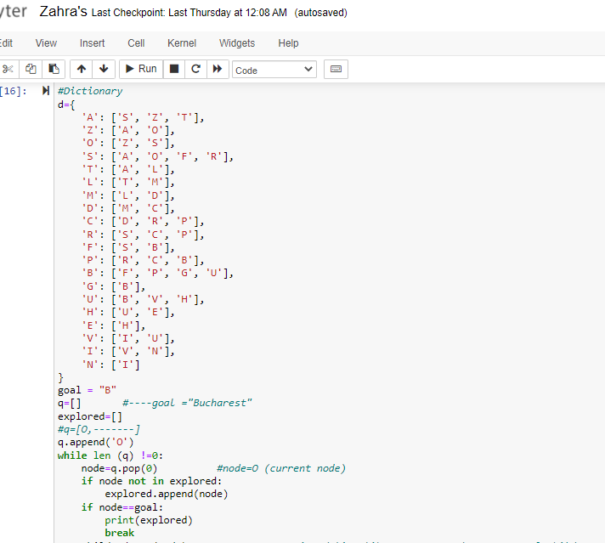

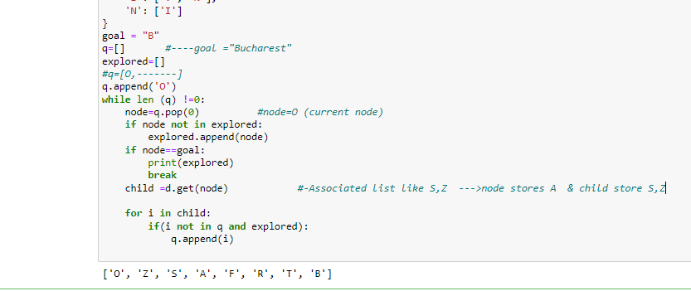

1. Apply BFS on given graph by considering the starting node as Neamt and goal node as Bucharest.

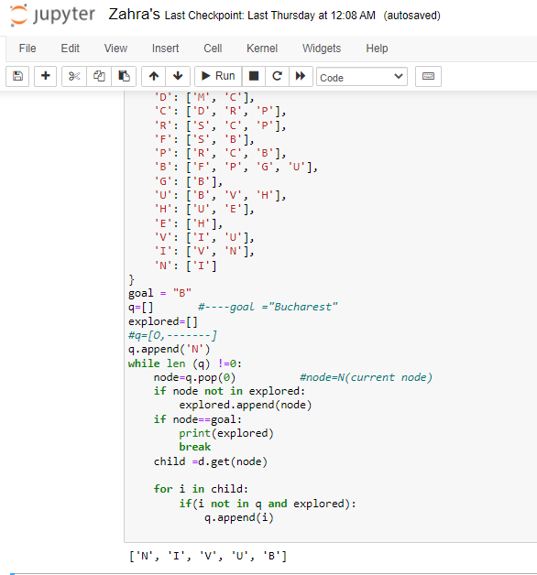

1. Apply BFS on given graph by considering the starting node as Timisoara and goal node as Bucharest.

